Chapter 4 – Philosophical Poems

My favorite poems are in this collection as they show Bernice’s inner life. Unlike the somewhat saccharine sentiment of many of the personal poems, these come across as authentic views of her spirituality. Some are positive, such as “Towards the Sun” and others are darker, such as “During the Gray Hour.” “The Concert” tells an imagined story, but ends as an allegory. All of them reflect a lot of thought and self-contemplation.

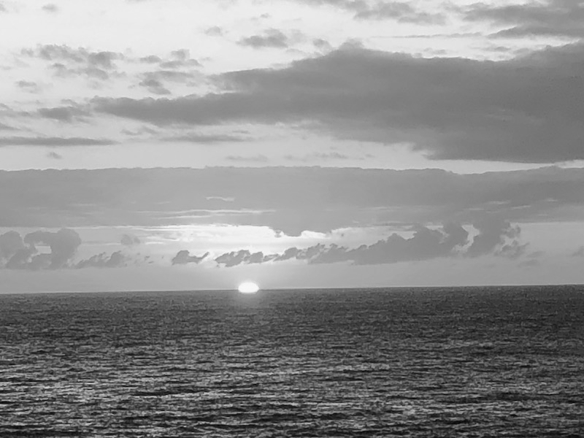
Sunset, photo by Ginger Wolnik

Towards the Sun

Let us go towards the sun… to brighter days –
Even though the toils of life bring on the night,
When our heart dreams about happiness…
Let us go forth boldly, believing in the power of the spirit!

Let us go towards the sun… though we are choking on our tears,
Though in our labor, sweat pours down our brow, –
Though the fruit of our labor is the gray dust⁷⁸ of our existence,
Though our hands are bloodied by the heavy hammer of our work!

Let us go towards the sun… to the brightest skies, –
Like winged birds flying to their nests…
Even though our daily bread is watered with tears,
Let us go with endurance, to the brightest stars!

Let us go towards the sun… above the earth at dawn, –
So that we may shake off the dirt of any blame,
And earn a better life for us there…
We will receive our reward, for our life’s toil!⁷⁹

Let us go towards heaven… where there are no more tears, –
Where there is no toil, amid the brightest ways…
After our pains and toils – we will reach life’s end,
When the world has harmed us, – God’s reward will all amend!

By Bronisława Wolnik
On the Waves of Life

On the waves of life – sailing with great difficulty,
You are tossed by fate, like a boat tossed by the waves,
Even though you are weary, you keep sailing into the distance with perseverance,
Although people may refuse to come to your aid.⁸⁰

Life is a great and open book,
On whose pages you will find enough disappointments
In your endeavors, in your quest for happiness,
Day passes after day, like a page turned after page.

But you should endure steadfastly at the helm of your boat,
Even though in the turbulent currents of the ocean
You will encounter cruel fate in life,
And even though fear tempts you to relinquish the helm.

For after all, we have our guiding star
Amid life’s difficulties, that we may not perish,
But gazing at it, we may keep sailing through the thunderstorm,
So let it be your torch⁸¹ and your shield.

That star, which is called the star of the sea,
Is the hope – that you will go around the dangerous rocks,
And you will arrive victorious at the shore,
Even though today the way is difficult and unknown.

Although your life is arduous, although the thunder roars –
Although pain and fear envelop your heart,
Oh, do not allow despair into your soul!
Because only the strong, will live and gain victory…

By Bronisława Wolnik
With Sunset

When, having finished its journey for the day,
The sun hides far beyond the darkest forest,
I also yearn for relief from my life’s toil,
In my pained soul – and with my sick heart.

And, seeing those last fading rays,
The blood-red radiance of the setting sun,
Oh! If only I could earn such grace
To rise up into space – to hear the heavens’ song.

If only I could be a bluish cloud in the sky,
Or a golden star shining in the night –
Because this earthly life is so hard
Amid such heavy work… infirmity and suffering…

I do not fear death – I will feel relieved
In blissful rest, after the parched day of my life,
Even though to those who were my most beloved
I will leave sadness… and great heartache…

By Bronisława Wolnik
During the Gray Hour

At the gray hour, all around there is silence,
But my heart is filled with a kind of sadness –
Longing for my country, longing for my family,
Or perhaps for the sun, hidden in the darkness.
Even though all around me everything is silent,
So quiet that I can hear my own heartbeat,
Something is distracting me from my sweet daydream –
It must be all the worries of my life.
But during this gray hour, I always remember
That brief bright moment of my happiness.
Even though my tears flow at its recollection,
Through tears, I can still see its reflection.
And although I do not know if I will see the day
When again for me the sun will shine,
I no longer cry for my happiness,
Because I know that it does not shine for a long time…

By Bronisława Wolnik
Autumn

Summer has passed – now the autumn’s here,
The leaves have fallen – flowers have withered away,
And such an emptiness has appeared in the world –
The flowers have gone. They have been laid to sleep.

The autumn wind whips and roars with cold –
The life of green plants and flowers has been destroyed,
And this tells us that everything that lives
Will wither, pass away – the end of life will draw near.

The autumn wind, a gray rainy day,
The rain rings on the windowpanes and pierces us with cold;
Listening to its mysterious words…
How I regret the summer and the sun.

And although sometimes the sun smiles for me,
Caressing the earth with its bright rays,
I hear the echoes of dry stalks of flowers cracking –
Among them, some kind of painful whispering…

I hear their complaints – and I ponder them –
My chest is weighed down with sadness and longing –
Why do you pass away, oh flowers, who adorn the earth?!
Only to awaken again, to life in the world.

That is how I think of the life that passes away –
But in the spring, the flowers will bloom again,
And green will cover the trees that are now bare,
Because they do not depart from us to a different world.

But when autumn comes in human life,
The end of life will come and lay us in the grave,
We will not rise with the flowers in the spring,
We will awaken from sleep – but at God’s Judgement Day.

By Bronisława Wolnik
The Mirages of Youth

Youth is a life full of mirages,
When the spirit wants to soar far – to the heights,
And it is full of illusion that it is already in control,
That already its mirages are obedient to action.

And there is so much splendor in these lofty aspirations,
Clothed in the rainbow of faith – in the hope
That already, arm in arm in brotherhood, we will attain
Happiness that nothing will disperse.

On the wings of the spirit, floating in high heaven,
We are so joyful – in the light of the blue skies,
We want to encompass the lands and the seas –
Or to reach the summits of sky-high mountains.

Oh, how beautiful this world is! This life –
The charm of youth entices us – beckons,
Because only youth is our happiness,
Which when it passes – will never return.

Floating in the clouds of the life of youth,
We build the lofty altars of ideals,
We want to make the happiness of mankind endure,
We dream of turning our mirages into action.

How wonderful are the dreams of our youth,
The world is so beautiful! Just like a rose flower,
It is full of rapture – strength, talent,
So how can we think of the storms of life?

But with the passage of time – when the storms come,
May no difficulty in life wear us down,
Life has its thorns – just like the rose flowers…
Then let us think – happiness – mirages…⁸²

By Bronisława Wolnik, 1935
To Our Youth

Why is there so much evil in the world?
Robbery and crime and bad habits,
Fashionable outings; the flower of our youth,
Seemingly educated, gathers in taverns;
The era of progress permits everything,
Our sons and daughters are tainted by debauchery.

Today, mother and father have no faith,
When they want to turn their children back from evil ways,
These are the times of science, of progress; so the old
Superstition, ignorance are evil old gods!
Raise the tankards higher – this is mad play,
The boy and the girl have equal rights.

Oh youth, why on butterfly’s wings
Do you carry our young people to perish in the wilderness?
And after a wild party when a bad moment comes –
Or maybe this is only God’s stern punishment?
Such a moment has made many a girl lose her life,
Or made a criminal of a young man.⁸³

Dear young people! You are of Polish ancestral blood,⁸⁴
Remember, that our hope lies in you,
May God’s mercy keep watch over you!
Let your future not scare your fathers,
Have a good time – but be careful! – Observe good warnings,
So that you will not get lost – do not go down the evil path!

By Bronisława Wolnik
The Concert

The concert hall is almost full now,
Lit up by sparkling chandeliers,
The audience is waiting, daydreaming –
The posters have announced the concert.

Suddenly the lights dim, the dusky hall is silent,
The orchestra starts playing on the podium,⁸⁵
It rouses the sweetness of memories in our hearts,
The lively melody flows quickly.

Now we can hear how the piano sobs softly,
Or how the waves roar – the wind hums…
That’s how the piano keys – made of ebony,
Speak, ring under the pianist’s fingers.

Now, the violin bow trembles amorously –
It awakens passion – its magic charm flows…
Just like a maiden in the spring of life,
It quenches the soul’s thirst – like nectar.

Now, a ballet dancer like a nymph,
Twirls gracefully, with mysterious gestures,
Slender as the slightest breeze blowing,
She bows, she threatens, she entreats.

The vision of the dancer fades away,
Again the piano begins to speak,
A wondrous melody is heard far and wide,
It’s time for a marvelous fairy tale…

The sweet song flows – a children’s tale,
Beginning with the speech of angels,
So marvelous! And innocent,
Oh, look! – It is only a girl singing.

The piano holds the chord, attentively –
The singing feeds us with its charm… like nectar,
It is HE – he’s singing her a love song,
The song flows with adoration – and passion.

And he, by God’s grace an artist,
Sings as if with unearthly speech,
And his reward is the applause…
For his loving heart, and his healthy youth.

_____

Oh, wondrous song! You are angelic!
You lead us far… to great heights,
You give us sweetness – the joy of a child
Upon its mother’s bosom, those sweet hours.

But everything passes, the magic fades away –
The concert hall is empty now, the night is silent –
But somewhere on the hall’s cornice, still alive –
The echo of the song trembles… slowly dies…

_____

As if it were a human soul…

By Bronisława Wolnik
Smiles

Is there anything sweeter than a baby’s smile?
When the mother, standing over its cradle,
Bending down low with tenderness in her heart,
Sees that angelic, innocent smile.

Is there a more joyful playfulness on earth?
When a group of happy children, laughing out loud –
So playful, shouting – and lively,
Are under their mother’s care, which is like rays of sunshine.

To what can we compare a young maiden’s smiles?
Which can be heard all around – all day long,
She is so free – charming, joyful,
With a song on her lips like a nightingale’s trills…

Although she seems to be fickle in her smiles,
And she bestows her smiles on everybody,
She will wound many a heart with her guiles,
But he with whom she truly falls in love will be happy.

Is there anything dearer than a woman’s smile?
When she greets her husband whom she has missed with longing –
And with this smile, she comforts and assuages…
His bitter pain – his life’s troubles.

And when she rests after her hard day’s toil,
In the quiet peace of her home hearth –
Her heartfelt smile blossoms on her lips,
May all people have – such nice smiles.

There is the smile of fate – on life’s road,
When happiness shines for you like a small flame,
And entices you with its light, as if it were charmed –
Just like the caresses of your beloved…

Even though the smile of fate shines out – then fades,
Like a lightning bug⁸⁶ flashing on Midsummer Night –
It contains as much happiness, hope and power,
As in our childhood, did wondrous fairy tales…

By Bronisława Wolnik
The Silence of the Night

When the starry night, lit up by moonlight,
Has rocked to quiet sleep the cradle of the earth…
Just like in a beautiful landscape painting,
The Divine Artist, gives people silence.

And a mysterious bliss trembles in the air, –
With my hidden hope for a better tomorrow,
Even if all day I have felt the severity of life,
The night will embrace me like my mother’s arms.

Let others play madly, boisterously,
Drinking goblets of wine, breathless with happiness,
As for me, I love silence. – When I feel worn out,
Under the canopy of stars, my dreams rock me to sleep…

Oh, blissful silence! Oh, starry night. –
In my dreams you let me forget my toils,
My path then shines bright and radiant for me…
As if I were walking amid the gardens of paradise!

Oh, thou bright night, – moonlit night,
Embrace the sick and the suffering in blissful sleep,
Let the white satin hand of an angel
Comfort their pain, – and wipe away their tears.

Let the moon keep watch… let the stars sparkle…
For the person whose soul is being killed by despair, –
Let him fall asleep in silence and wake up with power!
And may misfortune stay away from all people.

By Bronisława Wolnik

