Chapter 7 – Social Justice Poems

These poems were written during the Great Depression and reflect Bernice’s concern for the welfare of her community and the city of Chicago at large. Compared to many people at the time, she was relatively privileged because her husband always had a job, but she was acutely aware of the misfortune around her. Homelessness and alcohol/drug abuse are nothing new, so it was gratifying to learn that Bernice rose awareness of the plight of others through her rhymes. The final poem, “Help Us, Compatriots!” is about the 1934 summer flood, a long-forgotten tragedy immortalized by this work, which left many people in Poland homeless. The scrapbook also contained a newspaper clipping in English about this flood, along with a photo of barefoot peasants in line for food.

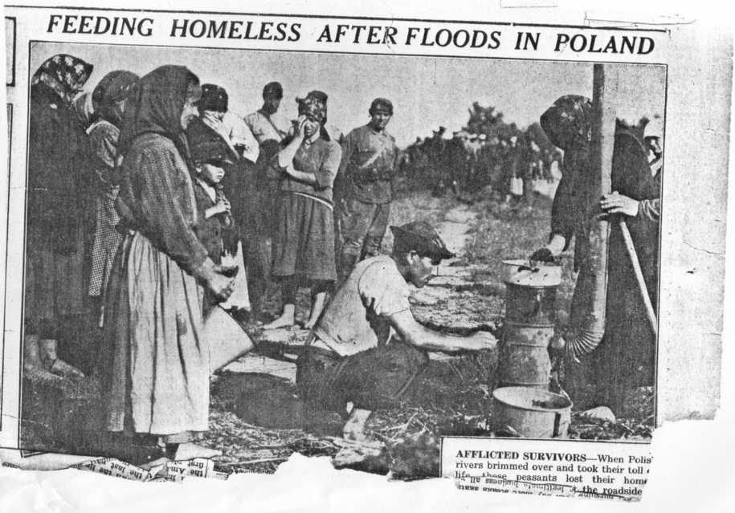
Newspaper clipping saved by Bernice Wolnik from 1934

Through My Rhymes

Oh! If only I could here, through my rhymes,
Speak to people with the words of angels,
To move their hearts, which are cold as rock,
Stone-cold – insensitive to human poverty.

Oh! If through my rhymes, I could
Kindle the fire of love among nations,
That they might love each other as brothers,
And together, rescue the unfortunate.

Oh! If only I could here, through my rhymes,
Comfort their pain – wipe away their tears on this earth,
Those people who have never experienced happiness,
Even though they worked for it by the sweat of their brow.

Oh! If through my rhymes, I could
Feed the hungry, those who are among us,
And clothe those who are freezing-cold – warm them with starlight,
Oh! If only rhymes could be active deeds.

Oh! If only through my rhymes, like balm¹¹⁴,
I could comfort their sadness,
And pour into their souls a great faith in God,
That their suffering – is the way to heaven.

By Bronisława Wolnik
To Autumn

Oh, Autumn! Thou mighty dispenser,
For some you generously pour out their measure
Of their abundant harvest, the fruit of their summer labor,
The fields of bread-giving grain, – happy are the peasants –

The farmer who sowed his fields in the spring
Diligently finishes gathering his harvest in the fall,
While during summer’s scorching hot long days
He used to go to work with the rising sun!

So in the fall too, he is full of hope –
That in the winter he will not hunger, will not suffer storms
But will enjoy a justly deserved rest
So that he can tend his fields again in the coming spring!

Oh, Autumn! For some, you are a generous master,
But how will you treat the poor in the cities?
In the summer, they used to sleep on the grass,
Using their own clothes as a blanket.

Thou, Autumn, who tear the leaves off the trees –
Why do you not clothe the poor people with the leaves?
Why do you not at least weave the airborne strands of gossamer¹¹⁵
Into shirts for those paupers who live in destitution.

Oh, Autumn! – Do not relinquish them to winter –
Because so many of them will die of cold and hunger!
But humanity is fertile. – So there will be no gap,
Thus it was in our forefathers’ time, and thus likewise do their descendants suffer.

By Bronisława Wolnik
The First Snowstorm

Outside, the first snowstorm was blowing crazily,
Pedestrians who were caught outdoors by the storm,
Who did not manage to come home in time,
Felt frozen through, shivering from the cold.

One could see the soft white sheets of snow,
Mercilessly upswept by the wind,
Which carried them – like entire clouds,
Creating mounds like snowy-white mountains.

The first snowstorm was blowing crazily,
The streets quickly fell silent – empty,
But somewhere in a tunnel, a small group of people was hiding away,
Those unfortunate people who have no home.

Their gaze is wild – their shoes completely worn,
A stinking rag hides their skinny body,
Their face is swollen, their hands are dirty,
They are deemed “vagrants” by the city.

These homeless people – despised by other men,
How cruel is their life’s fate!
After all, they too were born as children,
Why is this beautiful world, so sorrowful for them?

The first snowstorm was blowing crazily,
Even though merciless, it was full of charm,
The city folk greeted the white snow with joy,
While the homeless in the dusk, were filled with despair.

And many a homeless person, in the dark tunnel,
Had “visions” of their Mother¹¹⁶ – their childhood family home,
Amid the snowstorm – and the murmuring wind…
The “question” came to them, Why today am I without a home?

By Bronisława Wolnik
In Winter

Now a white shroud has covered the gray earth,
And just like a lover closely embracing his beloved,
He has softly clothed her naked shoulders,
And he listens to her complaints and her heartfelt sighs.

For how much suffering of misfortune there is on this earth!
When heavenly angels have spread out snow upon it,
The virgin snow, a blanket of heavenly whiteness,
Drinks up the tears of the earth, and of human bitterness.

Great was the joy with which children greeted it!
When they looked out from the windows of their warm apartments,
As the fluffy snow flew through the air, sparkling
In the form of tiny diamond stars, and softly crackling.

But other poor children, in a dark basement¹¹⁷,
Feel sad because the snowdrift will cover their little window,
And it is cold in their poor dwelling, the woodstove¹¹⁸ is not lit,
And trembling they cling for warmth to their mother.

And somewhere beyond the city there is a poor orphan,
Whose mother no longer comforts her in their little hut,
So she is walking to the city to seek servant’s work,
But will anybody take pity on her? Maybe…

She is walking, almost fainting from hunger, or from fatigue,
But now what?... her little head droops on her shoulders,
The unfortunate girl stoops down even lower,
Is she falling asleep on this empty road?...

The misty cloud of snow wildly blows all around,
Soon it will softly clothe the unfortunate girl…
For who can provide a more beautiful tomb for the orphan
But the soft white shroud of the winter snow?

By Bronisław¹¹⁹ Wolnik
To Winter

Oh, Winter, you mighty, splendid queen,
clothed in your soft coat of downy snow,
ice is your scepter – the frost, at your word,
congeals in the air to a silvery dust of stars
that sparkle in the sun like diamonds,
rendering pale the stars in the azure sky,
and the world appears as an enchanted palace
in the gleam of the moon that floats up above.
Soon the illusion of your majesty will pale,
which seems so splendid to behold;
look: I will show you the fate of these common people,
hungry paupers, who cannot hide
from your biting frost, amid the snowstorm.
Look: what a terrible despair shines in their eyes,
and under their torn and dirty rags,
what a dry skeleton, as if already frozen…
Such a man walks on the sidewalk, stumbling in circles,
perhaps drunk – as vagabonds are wont to be;
but I will tell you that they are not all like that,
because among them there are – oh, the deeply destitute!
Some are homeless, while in others’ dwelling
there are several children – among them, their mother;
their faces are sad, and in the bed in the corner
lies an old woman – near the end of her life.
It is so very cold there, the woodstove¹¹⁸ is not lit,
the air is stale, there’s not a crumb of bread,
and soon starvation will lay them all to bed.
Have mercy… people! give them what they need!

By Br[onisława] Wolnik
To Winter, 1935 ¹²⁰

Oh, frosty Winter – Thou splendid queen!
Clothed in your soft coat of downy snow,
Ice is your scepter – the frost, at your word,
In the air congeals in a silvery dust of stars
That sparkle like diamonds…
Rendering pale the stars in the azure sky,
And the world appears as an enchanted palace
On a magical moonlit night.

But the magic of your majesty will pale,
Which seems so splendid for us to behold.
Looking at the fate of the poor common people –
Why does your icy heart not melt?
Seeing the paupers – and their pallid children.
In the stale air of their apartment, a family crowds
Around the heater, where a small flame burns;
They are so hungry – and blue from the cold.

There are several members of the family – joy does not live here,
Nor does the magic of winter brighten their faces,
Because the feeling for its beauty has died in them,
The despair of destitution has overwhelmed their hearts,
And numbed them to the world, to life –
Their callused hands are clenched bitterly,
Because there is no work today, so necessary
For their happiness; they cannot find a job.

Oh, magical Winter, splendid queen,
In your icy life your heart does not beat,
But why do the rich and powerful clad their hearts
With a coat of ice? The rich man lives in prosperity,
Has never known poverty, so he is hostile towards the hungry,
Even though he has enriched himself by their work,
Today his human feelings have turned to ice,
And amid his riches, he has lost his heart.

By Bronisława Wolnik, 1935
Welcome, the New Year!

Today at midnight, the New Year¹²¹ is born,
He will strike the clocks with the mattock¹²² of time,
One thousand nine hundred and thirty-five,
The New Year is running towards us like a little child…

He is so joyous – and so sunny,
All radiant with happiness, although he is small,
That he will be warmhearted and generous to us,
With great joy! The whole world welcomes him.

Vivat! Long may he live! The dear child – the New Year,
Today may the old days of misfortune end,
Because in the new year, the happy hour
Will remove poverty – and comfort pain.

Today is joyful, amid blissful hope,
Humankind is lifted up to heights of happiness,
With encouragement in their heart – they aspire in the direction
Where the bright star is a leader to action.

Long may he live, the new light already shines in darkness,
We need to forget everything that pains us,
In the new year, to go forth boldly with faith,
Because the star of a better fate has already appeared.

So all of us together, let’s join our brotherly hands,
Let us go forth with eyes firmly fixed on the place of radiant dawn,
The star of hope is burning in the New Year,
That our tears will be dried – and happiness will greet us…

Let brotherly love embrace in its arms
All humankind, that until now drank fraternal blood,
Let our hope be fulfilled,
That amid poverty, crime may not be born.

So today let us welcome this New Year,
Which begins a new page of his history,
And may a better time come for us – of celebration,
The hour has struck of a happier destiny!...

By Bronisława Wolnik, 1934
In the New Year

What are you bringing us – oh, New Year?
the treasures of happiness… the wellspring of joy?
Because the celebratory sign of hope,
the eternal mirage – has come to visit us.

Oh, New Year, transform the mirages
of those hopes of years gone by –
Let happiness appear,
let it shine from the rainbows of dreams!

Happiness – but what kind? What do we need?
for there are so many luxuries!
The heavens have bestowed… pearls, gold,
One only needs to know how to take it boldly.

So they accumulate the shining gold,
The crowd of fat cats is dancing the tango,
While the working people know no mercy,
And their complaint – is a voice in the wilderness!

Every year there are different promises,
And illusions of the hope of happiness –
That the New Year has a treasury,
those are the deceptions of brotherhood.

Because unfortunately the sign of brotherhood,
That is also a mirage –
There is ever more fraud,
the golden calf has its altars!

For some, the shining gold is sown…
they drink from the cup of the joys of life,
While for others there are hopes –
They have faith in the happiness of heavens,

Oh, Thou great Creator God!
who created heaven and earth…
In the New Year, may humankind
watch a bright dawn!

In the New Year, may the tears…
of despair not flow among the poor,
May the starving children not perish
in so many unemployed families.

Oh, Great God, in the New Year,
Let brotherhood unite the world,
From the dark night of egotism –
Let the lovely day of happiness shine forth!

By Bronisława Wolnik
Quo Vadis? ¹²³

Oh, whither goest Thou? Thou, oh great Nation!
What paths do you take that you err in the darkness –
Oh, America! Why, in your forward march today,
Are there no rallying cries of equality and brotherhood.

The paths of your past deeds are covered with weeds,
Because the leaders keep erring – they have lost their way,
Oh, have pity! On your sons,
Let their elected ones give counsel – not judgment.

Oh, beautiful country! Flowing with milk and honey,
But why do you hold so many complaints in your bosom?
You are so rich, with gold, and the earth’s harvest, –
When will you fulfill the hopes of your people?

What has become of your noble dogmas?
That were left to us – by Father Washington,¹²⁴
Are those most beautiful virtues out of fashion now,
That are finer than the scepter or the crown!

Let the enlightened spirit of Great Lincoln¹²⁵
Show that this is not the place for white slavery,
Here, where the freedom of black people was proclaimed, –
That this country is the heritage of all the people.

Whither goest Thou? Come back from your path, or you will lose your way!
Your healthy people will perish, discouraged from living,
And by harming your people, you will stain the history of the country,
By preparing it for poverty – instead of the good life, happiness.

By Bronisława Wolnik
Help Us, Compatriots!

Help us, Compatriots!
This voice calls out from our Motherland –
The harvest of our hard work is destroyed,
Waters have flooded our villages…¹²⁶

The vast expanse of the sky started weeping –
Torrents of rain started to pour,
Even though the power of God is over us,
The forceful waters have gone wild…

The rivers so overflowing with water,
Thundered with a terrible force,
Flooding the wide land,
They tore down levees and dams.

Roaring fiercely, they took away
Our possessions – our cottages, our harvest,
The wild force of terrible waters,
Has driven the people from their homes.

In places where, peacefully amid hard work,
The pious peasants once lived,
Trusting in God, sleeping in peace,
After their hard, tiring day’s labor.

Now without a roof over their heads, without bread,
Everywhere, all around is the expanse of flood waters,
The fertile soil is full of alluvial silt,
Entire villages are destroyed.

So what if the sun will shine again,
Here it is finished – the harvest –
Mothers and children cry from hunger,
And now death will take them.

Help us, oh Compatriots!
Their voice begging flies to us…
From the Polish Land: Our brothers
Ask for this help – and their children…

By Bronisława Wolnik, 1934

