Introduction
by Ginger Wolnik
November 23, 2025

Bernice Wolnik was my father's mother, who died when I was just four. Growing up, I thought I had some direct recollections of her, but now I suspect they were probably just memories of photos and home movies that my father took. As a child, I thought she was very old and that is how she looked in those photos. When I got older, it was a shock to discover that Bernice was just 61 years old when she died in 1959. Her husband, my grandfather Joseph Wolnik, died one month before her, at age 72. They both died from a stroke, although my father said that his mother died of a broken heart.

Until recently, all my information about my Grandma Wolnik was from stories my father told me. After my father died, I found some paperwork about his mother that confirmed those stories, such as her baptismal certificate and her immigration papers. Online genealogy research has produced additional information such as census records. Another source was her scrapbook, filled with cryptic Polish newspaper clippings, which were mostly her poems she published. From all this, I've been able to piece together her life story.

Bernice (Bronisława in Polish) Rogóż was born in 1897 on a farm in the small village of Borzęcin in southern Poland, which was then part of the Austro-Hungarian Empire region of Galicia. She was the first child of Andrew (Andrzej in Polish) Rogóż, who was 31 and Victoria (Wiktoria in Polish) Wojdak, who was 25 when Bernice was born. She had a younger sister nicknamed Wikta and a younger brother named Poldus, which may have been a nickname for Leopold. Being much older than her brother, Bernice had to help on the farm and do some of the work that a boy would have normally done, such as harness the horses. The farmhouse had a dirt floor, but in spite of their poverty, Bernice went to school, presumably the Catholic grammar school in town. She was very religious her whole life, probably because of her schooling.

When Bernice was 24, she overheard her parents saying they would not allow her to get married because they needed her to care for them as they aged. At that point, her parents were 55 and 49 years old, which is middle-aged today, but would have been getting elderly in that time and place. Bernice's younger sister had already run off with a local boy and got married; I assume she got pregnant so her parents had no choice but to let her leave. Since Bernice was the "good" daughter, she felt doomed to be a spinster.

Galicia was always the poorest part of Poland, but during World War I, it was devastated by battles and repeated occupations from both sides. After the war, Poland became a free and independent country, thanks to the Treaty of Versailles. Both before and after the war, there was an exodus of people fleeing impoverished Galicia for the United States, including some of Bernice’s relatives. In 1921 at age 24, one of Bernice’s relatives in Chicago sent her money so that she could join them in America. The immigration records list her passage as paid by John Rogosz, who was probably her cousin Jan Rogóż. Bernice was accompanied on the trip by Rosalia Solakowna, who was 20 years old and also from Borzęcin. Rosalia later married Tadeusz (Ted) Maheta in Chicago. She was known to my family as Rose Maheta and she remained close to Bernice throughout her life.

In those days, many Polish villages had travel agents who made all the arrangements, including train tickets and ship bookings. As part of their fee, tour agents would meet the traveling immigrants and help escort them to the next step of their long trip. Letters from America helped Bernice prepare for her epic journey, which started as travel by foot or horse cart to a nearby larger town with a rail station, probably Biadoliny Szlacheckie, which was 5 miles (8 km.) away. From there, she would have taken a train to Krakow, then transferred to a train going north to the Baltic Sea coast. Immigration records show that Bernice left Copenhagen aboard the Scandinavian America Line vessel Frederik VIII on Oct 29, 1921, and arrived in New York on Nov 8, 1921.My research found that the ship started in Copenhagen, so she must have taken a ferry or other vessel from Poland to that island port. From New York, she took a train to Chicago and was met by her cousin. Bernice got a job sewing in a sweatshop and paid her cousin back the money for her trip.

It did not take long for Bernice to have the life she wanted. She met Joseph Wolnik, another Polish immigrant from Galicia, and they got married on May 12, 1923. They had their first child a year later. Unfortunately, that baby girl died the next day. My father, Emil Wolnik, was born the following year and she had no other children. According to my father, Bernice always missed and grieved for her daughter. Through genealogy research, I discovered the baby’s death certificate online, which listed Saint Adalbert Catholic Cemetery as where she was buried. On my next trip to Chicago, I visited the cemetery hoping to find her grave. However, I learned that she had a “term burial” of just 20 years, which was a common way for poor immigrants in Chicago to afford a plot. The term was not renewed, so the site was reused over the original burial. Fortunately, term burials were discontinued in the 1950’s.

During the Great Depression, my grandpa Joseph Wolnik always had a job, so with only one child, the family was relatively well off. My grandfather was an unskilled laborer, working jobs like those in the Chicago stockyards. He probably did the grimy, dangerous work as described in Upton Sinclair's novel “The Jungle,” but compared to Bernice’s life in Poland, they were “rich!” They moved several times, renting flats in small apartment buildings in Polish neighborhoods. Bernice became a housewife, cooking and baking. My father’s favorite was plum dumplings, which he learned to make from his mother. They purchased their last home, which was a new brick house in the suburb of Franklin Park. This property had a garden in the backyard with peach and plum trees.

During the 1930’s, Bernice wrote poetry in Polish that was published in Polish language newspapers in Chicago. I inherited her scrapbook of these poems and for years, I wondered what they were about. When I retired, I finally had time to scan and organize the scrapbook in preparation for translation.

Bernice applied for U.S. citizenship in 1933, but remained active in the Polish-American community in Chicago. A 1935 article in her scrapbook lists her as the president of a local chapter of the Polish National Alliance. The Chicago chapter consisted of members from Bernice’s home village of Borzęcin. The chapter had just made an allocation of $5, which is equivalent in purchasing power to about $100 in 2022. The donation was toward the construction of a monument honoring Józef Piłsudski, who is considered the father of the Republic of Poland that was founded in 1918. The monument consisted of a pyramid shaped mound of dirt that is 35 meters (115 ft.) tall, with a granite tablet on top. The restored mound still stands today and is the largest of 4 historic mounds in Krakow!

Another article saved in Bernice’s scrapbook was about the 1936 installation banquet for the Legion of Polish Women. Here is a translation of a touching moment about her from that event: “The speech program was interwoven with beautiful singing by Mrs. Sophia Stonecka, who was gifted a flower bouquet and a recitation of a poem by Mrs. Bernice Wolnik, the author herself.”

An online search for her name found Bernice Wolnik in the Congressional Record for April 21, 1941. Bernice was listed as a board member of the Polish Women's Alliance of America, whose petition to help supply food to occupied Europe was submitted into the Record by an Illinois congressman. Another search result credited Bernice with writing the lyrics to a song titled “Marsz Wiankow” or “The March of the Flower Wreaths.”

I suspect that Bernice wrote more poems that were not saved. Her scrapbook was full, but ended in 1939. Was there another volume that did not survive? As more newspapers are digitized, it may become easier to search for them. It is also possible that with the outbreak of WWII, she moved her efforts from writing poetry to working for support of occupied Poland. My hope is that Bernice's poems will show what was important to her during her lifetime.

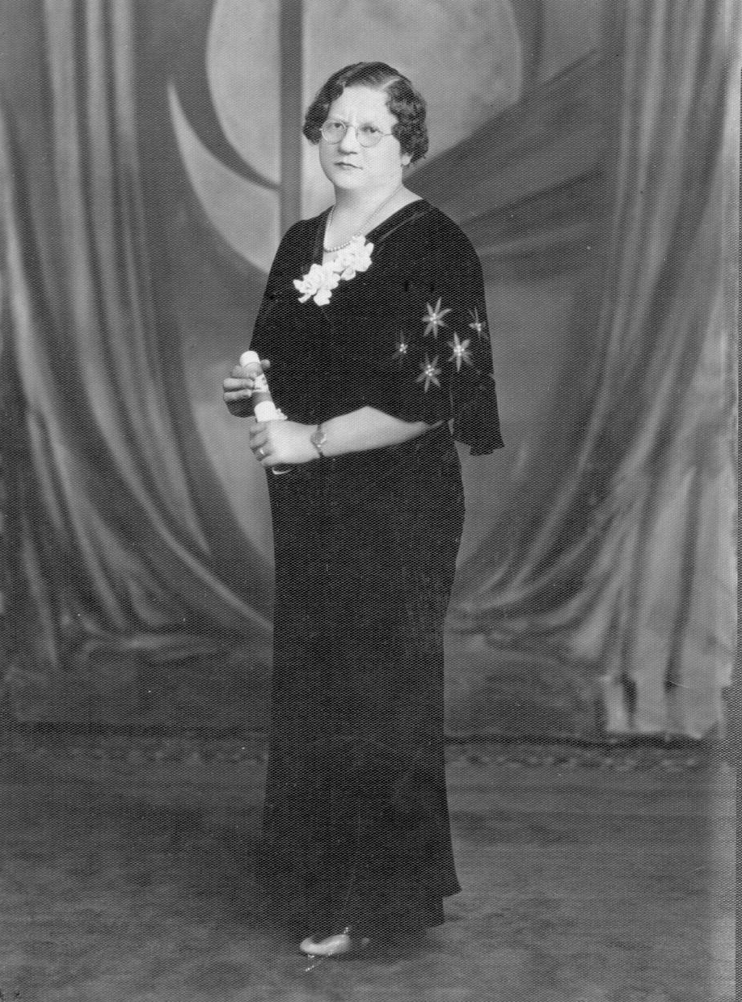
Bernice Wolnik July 27, 1935

